**Skwentna Tributary, AWC nomination**

8/14/2024

Coordinates: 61.98420, -152.00703 (upper sample site)

Data Sheet:

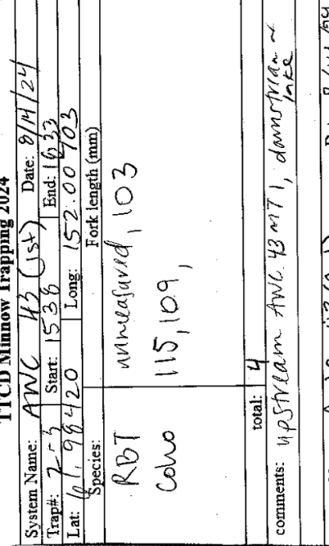

Coho parr captured in minnow traps. Traps were set from 1538-1833 on 8/14/24.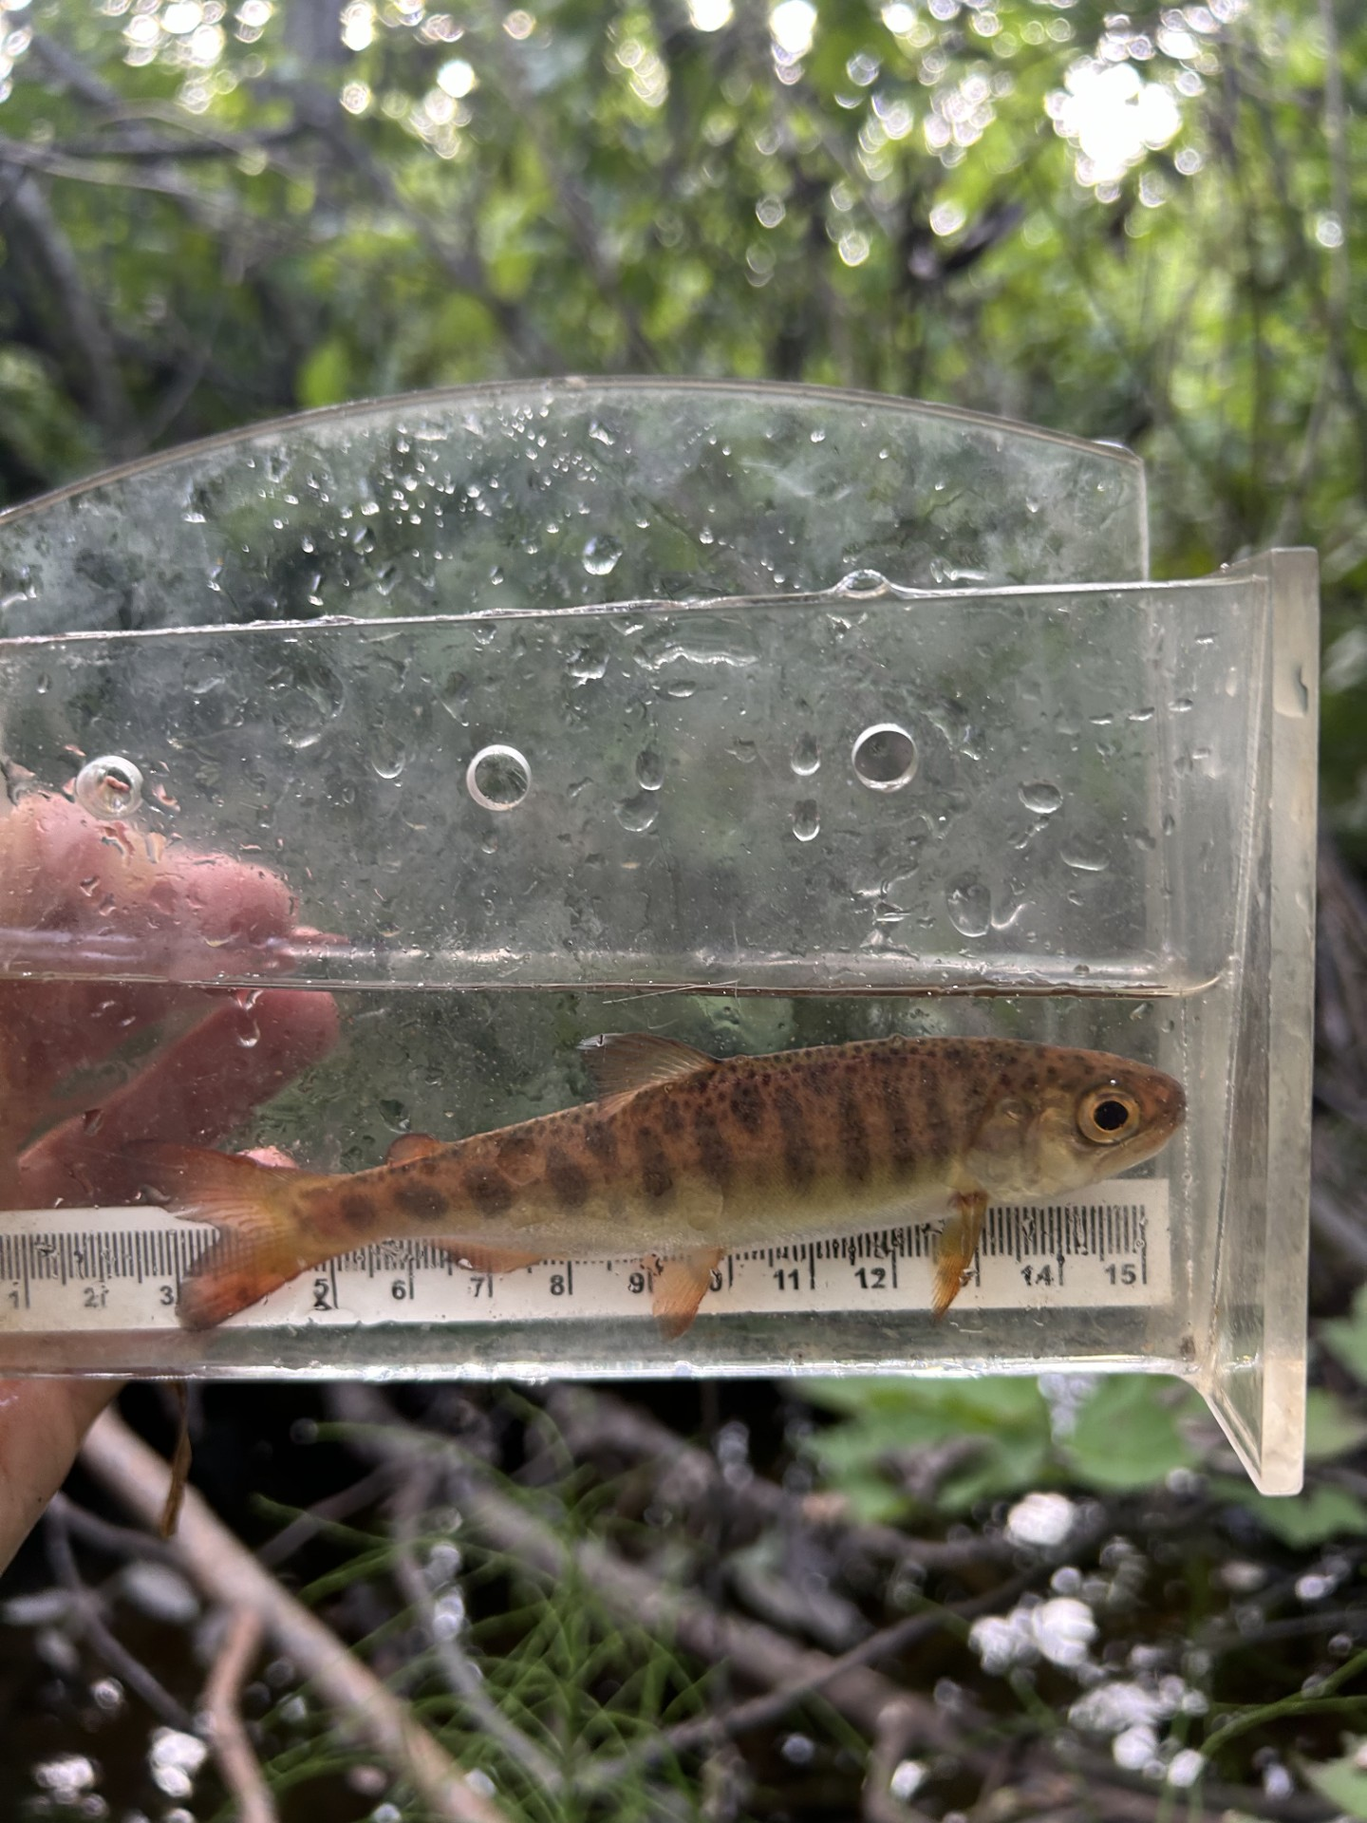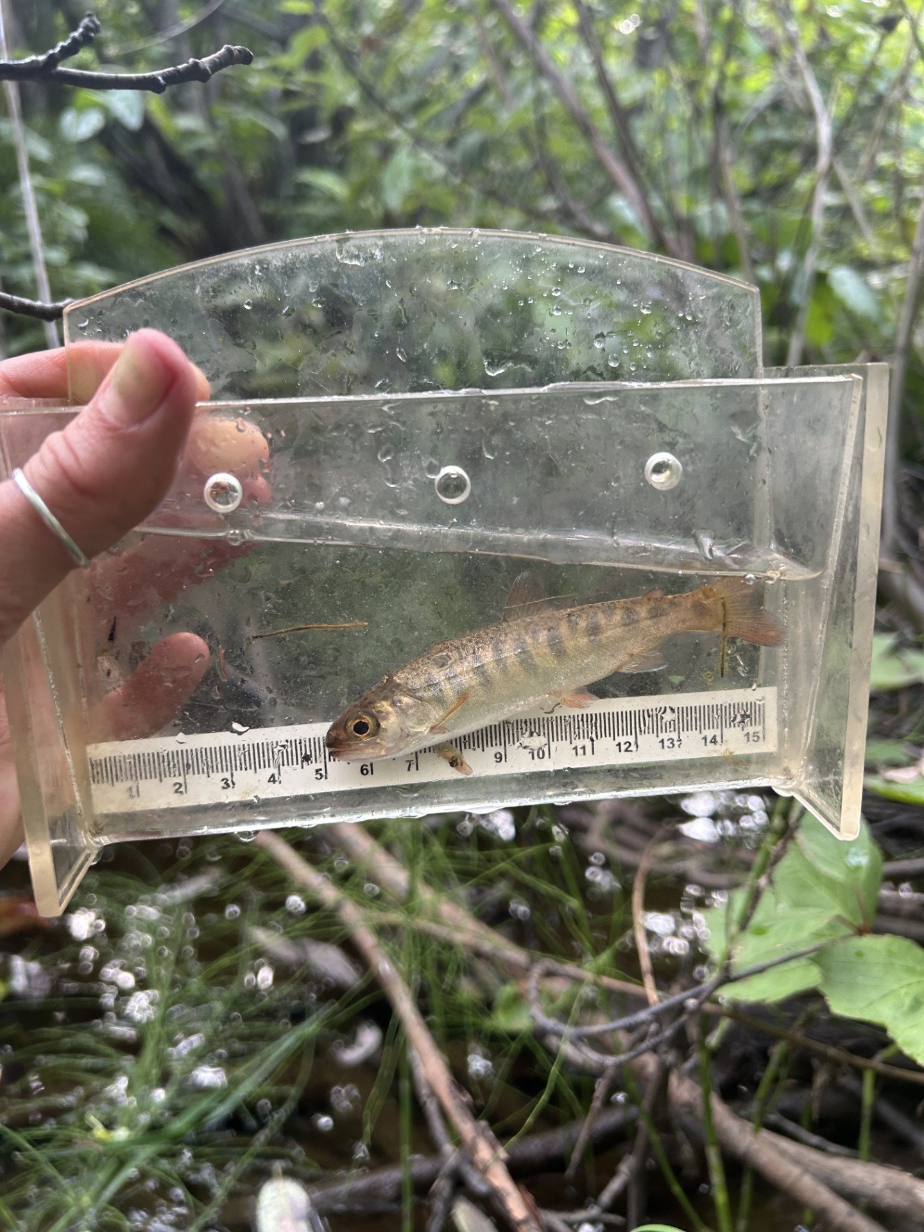

Map: Sample site where coho parr captured in minnow traps. Pinned sites are locations where traps containing coho were set in relation to tributary (upper reach of AWC stream 247-41-10200-2053-3205-4102).

